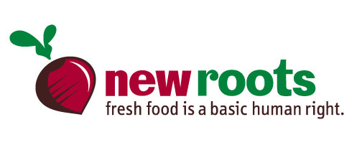

Amber Burns, Assistant Executive Director

***new roots, inc. and***

***fresh stop markets***

P.O. Box 4421

Louisville, Kentucky, 40204 USA

t. 502.295.6609

amber.burns@newroots.org

www.newroots.org

@newrootsky

facebook.com/newroots



Mary Montgomery, Uber Farmer Liaison

***new roots, inc. and***

***fresh stop markets***

P.O. Box 4421

Louisville, Kentucky, 40204 USA

t. 502.644.3354

mary.montgomery@newroots.org

www.newroots.org

@newrootsky

facebook.com/newroots



Karyn Moskowitz, Executive Director

***new roots, inc. and***

***fresh stop markets***

P.O. Box 4421

Louisville, Kentucky, 40204 USA

t. 502.475-8979

karyn.moskowitz@newroots.org

www.newroots.org

@newrootsky

facebook.com/newroots